

# Preface

This document contains information specific to the SBC sports wagering system and mobile application. The context of this document is that of user stories and use cases. This document is not meant to be absolute and can change at any time.

# Revisions

|  |  |  |
| --- | --- | --- |
| Author | Revision | Date |
| Scott Zizza | 1.0 a | 10-31-2014 |
|  |  |  |

# Table of Contents Home

### User Stories

* 1. About Screen
  2. Login Screen
  3. Create SBC Account
  4. Add Linked Account/Account Summary
  5. Sports Landing Screen
  6. Lines Screen
  7. Settings Screen
  8. History Screen
  9. Message Center (optional)
  10. Header
  11. Quick Menu

# User Stories

### About Screen

* Information about the app and the version and company.
* Contact emails and or a number.

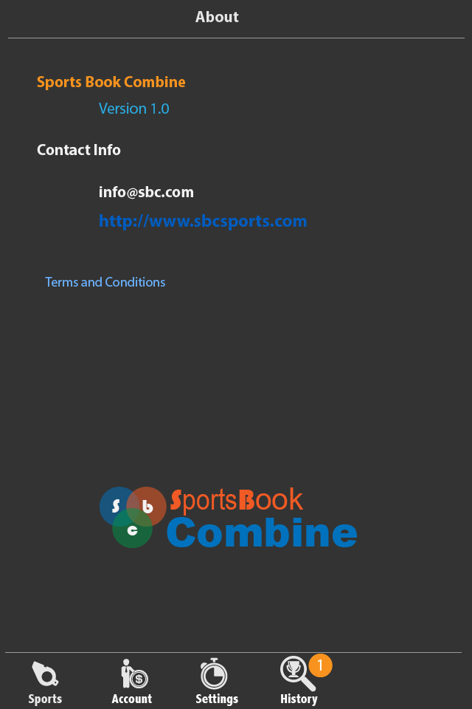

### Login

* The landing screen after the application opens.
* The user is prompted for their user name and password.
* The username/password is authenticated and if success will move on to the sports screen.
* If authentication fails the user is notified that the credentials are invalid.
* There is an option to create a new account if one doesn’t exist.
* This takes the user to create new account screen.
* There is an option for automatically logging the user on.
* There is an option to retrieve a lost password or forgotten user name. The notification to the user shall happen via email.

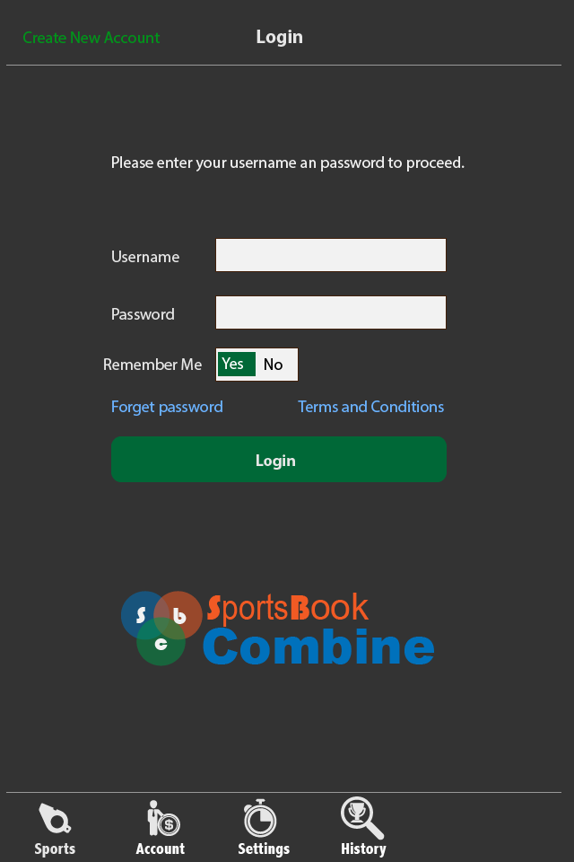

### Create New Account

* User will enter a username and a password - the password will need to be confirmed and match. if they do not match then the user will be prompted to renter the password.  The password field must be obstructed **** for example in lieu of the actual values.
* A CAPTCHA must be entered correctly.
* The user must provide a valid email address. This will need to be verified before the account can be activated by following a link.
* The user will need to provide a First and Last name along with a residing city, state and zip code.

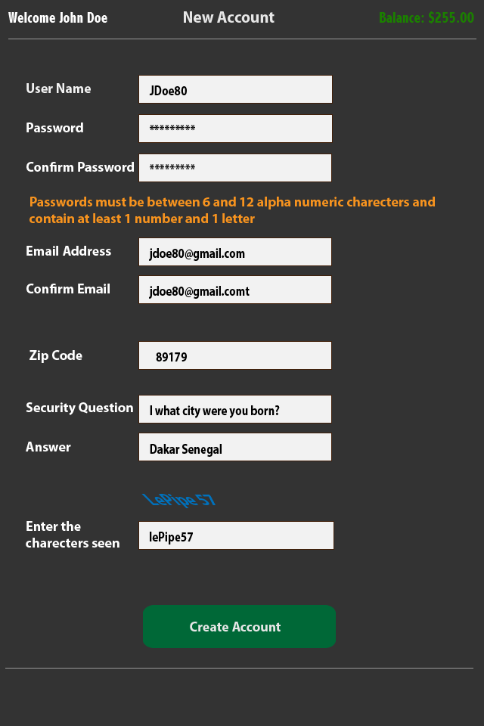

### Add Linked Account/Account Summary

* After the user creates a new account and he or she is verified and authenticated they will be able to add a linked account.
* Note: A linked account is an account owned by the user which is associated with one of the partner books. The use is required to provide the details for the account.
* The user will be able to add a linked account providing the hosting book (William Hill etc), their user name and password (password must be obstructed or obfuscated *** for example).
* The user will be able to edit or delete these accounts but only one account can be active at a time in order to prevent confusion.
* The page will also show the users account information and balance, username and obfuscated password. The user can edit the user information via an edit button.

### Sports Landing Screen

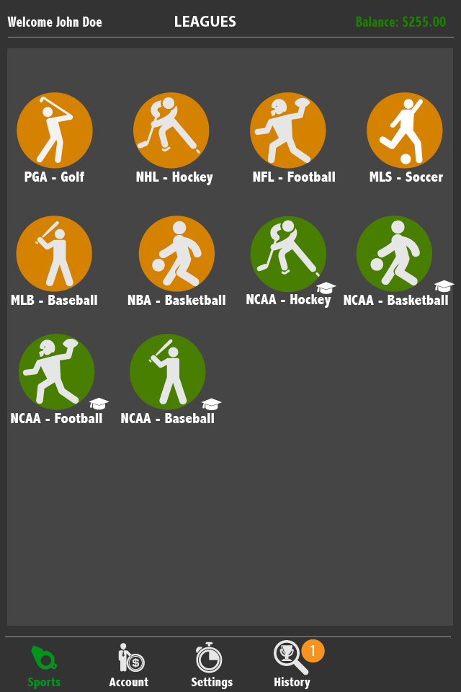

* The default header will be visible along with the quick menu.
* This will be the first screen the user sees when logging in. It will also be tied to a quick link tab in the menu area called ‘sports or leagues’.
* This screen will provide the user quick input to their favorite lines/bets. This screen will show all available sports categories or leagues by default but be customizable to show only the categories they are interested in by default. This customization will be available through the settings screen.
* The user can click on a category which will immediately take them to the lines screen pre filtered for that league/category.

### Lines screen

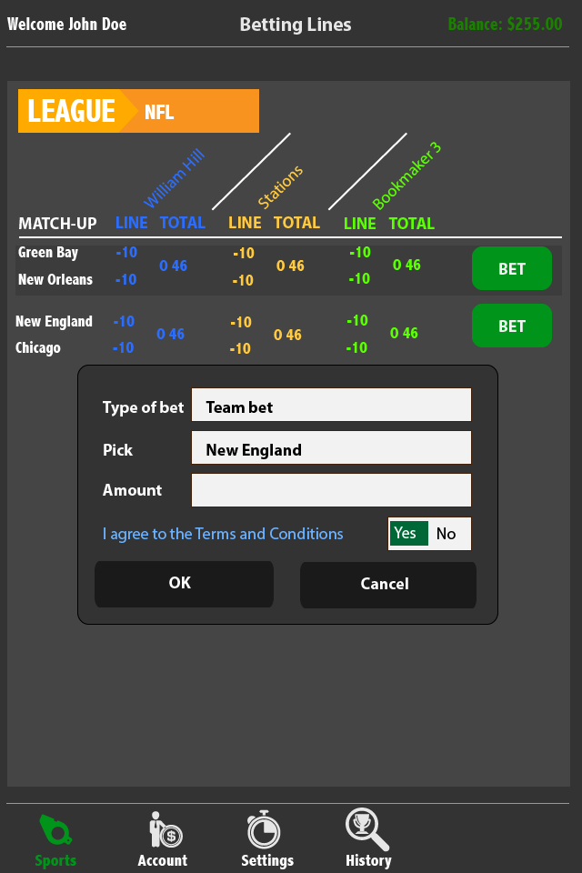

* This screen can be navigated through either through the ‘sports landing screen’ or through the quick menu at the bottom.
* If navigated through the sports landing screen the list and league will be repopulated with the previously selected category from the sports 'landing screen’.
* If this screen is navigated to via the quick menu then the user will need to select the league via a drop down box at the top.

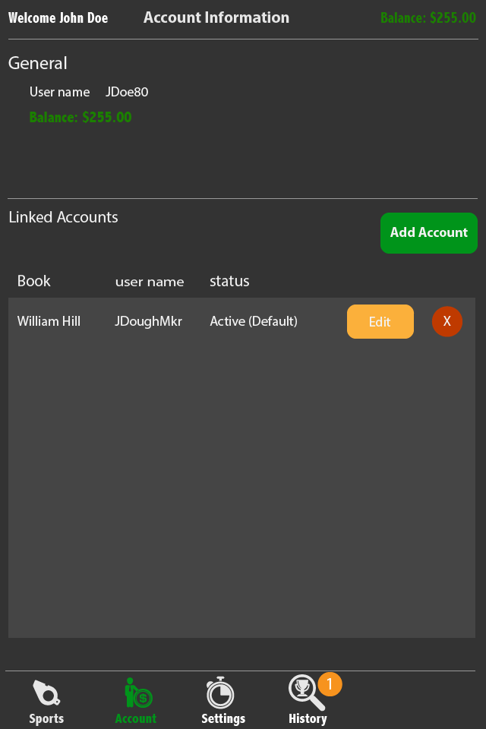

* Once a league is selected all available lines from participating books will be listed. The user will be able to see only the best lined determined by our algorithm. However, the user can drill down to view all available lines and have the option to choose any of those lines.
* The user can bet either the best lines or line of of his choosing and place a straight bet - a bet can be a straight bet which is a bet for a team to win or a bet on the over or under.
* Once the bet is selected and the book the user will enter the amount and confirm the bet by agreeing to the terms and conditions. Then the will be able to click ‘ok’ to place the bet. A confirmation from the system will be delivered once the bet is confirmed. If the confirmation takes longer than 30 seconds the bet will - if possible be rolled back and canceled and the user will be notified. If this can’t be done we will need to add this to the terms and agreement.

### Setting Screen

* This page has yet to be determined other than offering an option for the user to select which categories they want to show on their quick launch or ‘sports landing screen’ This will be a list with check boxes of all available leagues. It will also have an option for the user to select the default number of transactions per page the user wishes to see in their ‘history view'

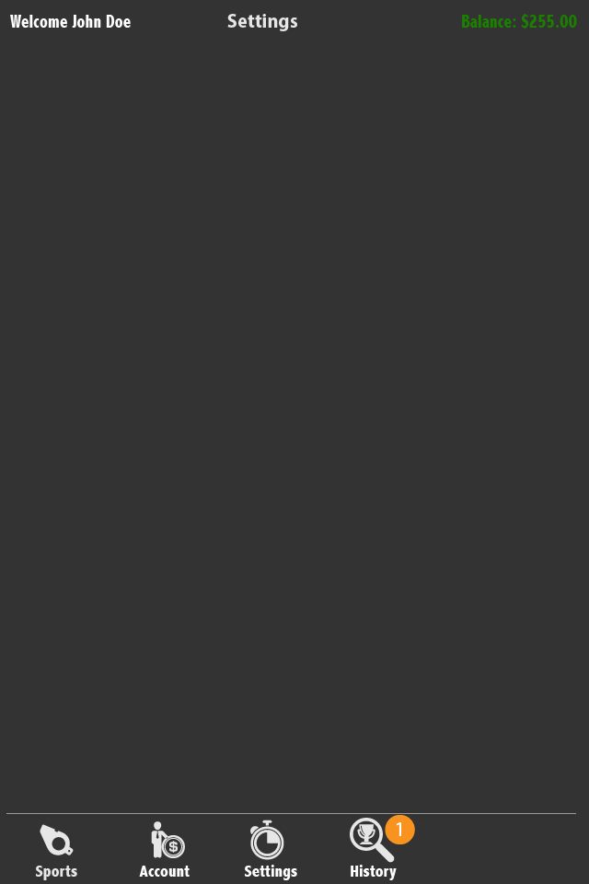

### History Screen

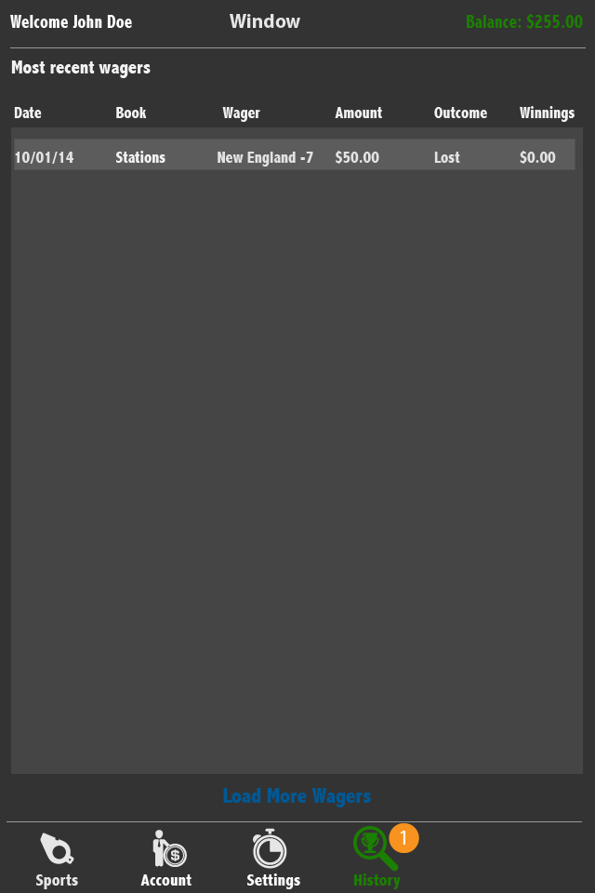

* This page will show the latest transactions/bets. It will be configurable in settings. It will show a list of x number transactions and will contain the following information; Date of bet, trxn #, book, matchup (teams),  the line, bet amount, the outcome, and winnings. An option for showing reduced info with the option to click and drill down should be considered.
* The user can click ‘show more transactions’ to load the next X transactions.
* The user will be able to dispute a transaction bet here. This will be done trough a dispute button at the bottom of the screen and by clicking they will be prompted to enter a transaction number and an explanation. This will be entered through a small popup screen. Dispute resolutions will occur through email or in app messaging system.

### Message Center (optional)

* This screen will show a list of messages sent and received ordered by date/time. The list will show the date/time, the subject and whether it was sent or received .
* The user will have the ability to message customer support about disputes or other application questions.
* When a message is sent the application will gather information such as user id and geo-location information.
* The user can select messages for operations such as delete via checkbox next to the message in the list.
* The user can delete a message, create a message, or reply to a message.
* Deletion will occur by selecting the message and clicking ‘delete’.
* Creation will occur by clicking ‘’create’ at which at popup will be displayed with a to, subject and message field.
* Replying to a message will be done by clicking on the message and selecting ‘reply'.

### Header

* The header is a standard display that will be atop of all pages except the add account and login screen. It will show the username the date and the balance of the active account.

### Quick Menu

* This is a navigation feature that will reside at the bottom of the app and will provide links to the following pages: sports/leagues, accounts, settings, history